AWS Certified Machine Learning—Specialty: Mini Practice Test - Results

Question 1Skipped
The data science team at a leading Questions and Answers website wants to improve the user experience and therefore would like to identify duplicate questions based on similarity of the text found in a given question.
As an ML Specialist, which SageMaker algorithm would you recommend to help solve this problem?
XGBoost
Factorization Machines
Correct answer
Object2Vec
BlazingText Word2Vec mode
Overall explanation
Correct option:
Object2Vec
Object2Vec can be used to find semantically similar objects such as questions. BlazingText Word2Vec can only find semantically similar words. Factorization Machines and XGBoost are not fit for this use-case.
Object2Vec : The Amazon SageMaker Object2Vec algorithm is a general-purpose neural embedding algorithm that is highly customizable. It can learn low-dimensional dense embeddings of high-dimensional objects. The embeddings are learned in a way that preserves the semantics of the relationship between pairs of objects in the original space in the embedding space. You can use the learned embeddings to efficiently compute nearest neighbors of objects and to visualize natural clusters of related objects in low-dimensional space, for example. You can also use the embeddings as features of the corresponding objects in downstream supervised tasks, such as classification or regression.
A good reference read for Object2Vec:
https://aws.amazon.com/blogs/machine-learning/introduction-to-amazon-sagemaker-object2vec/
Incorrect options:
Factorization Machines - The Factorization Machines algorithm is a general-purpose supervised learning algorithm that you can use for both classification and regression tasks. It is an extension of a linear model that is designed to capture interactions between features within high dimensional sparse datasets economically. For example, in a click prediction system, the Factorization Machines model can capture click rate patterns observed when ads from a certain ad-category are placed on pages from a certain page-category. Factorization machines are a good choice for tasks dealing with high dimensional sparse datasets, such as click prediction and item recommendation.

BlazingText Word2Vec mode - The Amazon SageMaker BlazingText algorithm provides highly optimized implementations of the Word2vec and text classification algorithms. The Word2vec algorithm is useful for many downstream natural language processing (NLP) tasks, such as sentiment analysis, named entity recognition, machine translation, etc. Text classification is an important task for applications that perform web searches, information retrieval, ranking, and document classification.
The Word2vec algorithm maps words to high-quality distributed vectors. The resulting vector representation of a word is called a word embedding. Words that are semantically similar correspond to vectors that are close together. That way, word embeddings capture the semantic relationships between words.

XGBoost - The XGBoost (eXtreme Gradient Boosting) is a popular and efficient open-source implementation of the gradient boosted trees algorithm. Gradient boosting is a supervised learning algorithm that attempts to accurately predict a target variable by combining an ensemble of estimates from a set of simpler and weaker models. The XGBoost algorithm performs well in machine learning competitions because of its robust handling of a variety of data types, relationships, distributions, and the variety of hyperparameters that you can fine-tune. You can use XGBoost for regression, classification (binary and multiclass), and ranking problems.
Domain
Modeling
Question 2Skipped
As part of a clinical study, you have processed millions of medical records with hundreds of features and reduced the feature dimensions to just two using a model based on Principal Component Analysis (PCA). The following graph illustrates the distribution from the PCA model output in the form of two distinct classes shown in red and blue dots.
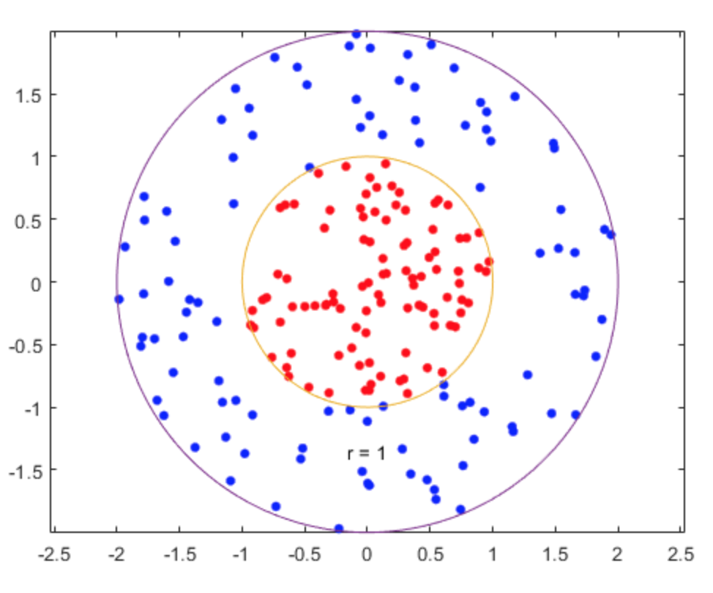
Which algorithm can you use to accurately classify the above output from the PCA model?
K-means
Correct answer
Support Vector Machine
Logistic Regression
Linear Regression
Overall explanation
Correct option:
Support Vector Machine
Principal Component Analysis (PCA) Algorithm—reduces the dimensionality (number of features) within a dataset by projecting data points onto the first few principal components. The objective is to retain as much information or variation as possible. For the given use-case, the features have been reduced to just two dimensions using a model based on Principal Component Analysis (PCA).
Support Vector Machine (SVM) is a supervised machine learning algorithm that can be employed for both classification and regression purposes. SVM can solve linear and non-linear problems and work well for many practical problems. SVM creates a line or a hyperplane which separates the data into classes.
SVM is used for text classification tasks such as category assignment, detecting spam and sentiment analysis. It is also commonly used for image recognition challenges, performing particularly well in aspect-based recognition and color-based classification.
Since SVM can classify for non-linear boundary, so that’s the right option.
Incorrect options:
Linear Regression - The output of a regression ML model is a numeric value for the model's prediction of the target. For example, if you are predicting housing prices, the prediction of the model could be a value such as $ 254,013. This is a classification problem, so Linear Regression can be ruled out.
K-means - It is an unsupervised learning algorithm. It attempts to find discrete groupings within data, where members of a group are as similar as possible to one another and as different as possible from members of other groups. You define the attributes that you want the algorithm to use to determine similarity.
Amazon SageMaker uses a modified version of the web-scale k-means clustering algorithm. Compared with the original version of the algorithm, the version used by Amazon SageMaker is more accurate. Like the original algorithm, it scales to massive datasets and delivers improvements in training time. As K-means is used for clustering, so this option is also incorrect for the given use-case.
Logistic Regression - This is a classification algorithm that is used where the response variable is categorical. As the decision boundary is non-linear, Logistic Regression is not the right fit for the given use-case.
References:
https://towardsdatascience.com/support-vector-machine-simply-explained-fee28eba5496
https://towardsdatascience.com/logistic-regression-detailed-overview-46c4da4303bc
https://docs.aws.amazon.com/machine-learning/latest/dg/learning-algorithm.html
https://docs.aws.amazon.com/sagemaker/latest/dg/k-means.html
https://aws.amazon.com/blogs/machine-learning/train-faster-more-flexible-models-with-amazon-sagemaker-linear-learner/
https://aws.amazon.com/blogs/machine-learning/amazon-sagemaker-supports-knn-classification-and-regression/
Domain
Exploratory Data Analysis
Question 3Skipped
A ride-hailing company needs to ingest and store certain attributes of real-time automobile health data which is in JSON format. The company does not want to manage the underlying infrastructure and it wants the data to be available for visualization on a near real time basis.
As an ML specialist, what is your recommendation so that the solution requires the least development time and infrastructure management?
Ingest the data into S3 using Kinesis Firehose. Launch a Glue ETL Job every 15 minutes to write S3 data into RDS. Use RDS Connector to visualize this data in QuickSight
Correct answer
Ingest the data using Kinesis Firehose that uses a Lambda function to write the selected attributes from the input data stream into an S3 location. Further pipe this processed data into QuickSight for visualizations
Ingest the data using a Spark Streaming application running on an EMR cluster. The output data with selected attributes is written in JSON format on S3. Further pipe this data as source into QuickSight for visualizations
Ingest the data using Kinesis Data Streams and pipe the data to a Glue Streaming Job to select specific attributes from the source data and write the output in another S3 location. Use this processed data in QuickSight for visualizations
Overall explanation
Correct option:
Ingest the data using Kinesis Firehose that uses a Lambda function to write the selected attributes from the input data stream into an S3 location. Further pipe this processed data into QuickSight for visualizations
Amazon Kinesis Data Firehose is the easiest way to load streaming data into data stores and analytics tools. Kinesis Data Firehose manages all underlying infrastructure, storage, networking, and configuration needed to capture and load your data into Amazon S3, Amazon Redshift, Amazon Elasticsearch Service, or Splunk. You do not have to worry about provisioning, deployment, ongoing maintenance of the hardware, software, or write any other application to manage this process.
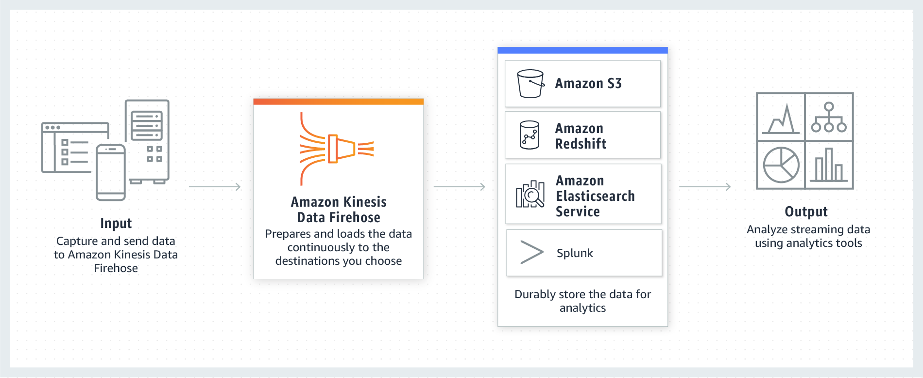
Amazon QuickSight is a scalable, serverless, embeddable, machine learning-powered business intelligence (BI) service built for the cloud. QuickSight lets you easily create and publish interactive BI dashboards that include Machine Learning-powered insights. QuickSight dashboards can be accessed from any device, and seamlessly embedded into your applications, portals, and websites.
This is the correct option as it can be used to process the streaming JSON data via Kinesis Firehose that uses a Lambda to write the selected attributes as JSON data into an S3 location. You should note that Firehose offers built-in integration with intermediary lambda functions to handle any transformations. This transformed data is then consumed in QuickSight for visualizations.
Incorrect options:
Ingest the data using Kinesis Data Streams and pipe the data to a Glue Streaming Job to select specific attributes from the source data and write the output in another S3 location. Use this processed data in QuickSight for visualizations - AWS Glue is a serverless data integration service that makes it easy to discover, prepare, and combine data for analytics, machine learning, and application development. AWS Glue provides all of the capabilities needed for data integration, so you can start analyzing your data and putting it to use in minutes instead of months.
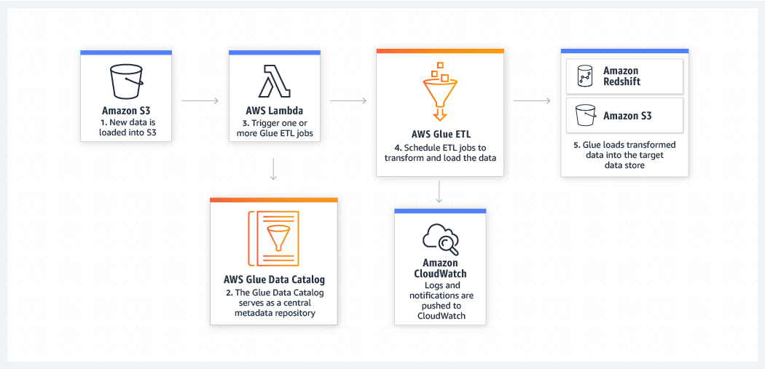
Glue ETL can be used for batch ETL use cases as well as processing real time data. You can create streaming extract, transform, and load (ETL) jobs that run continuously, consume data from streaming sources like Amazon Kinesis Data Streams, Apache Kafka, and Amazon Managed Streaming for Apache Kafka (Amazon MSK). The jobs cleanse and transform the data, and then load the results into Amazon S3 data lakes or JDBC data stores.
This option involves custom code development for the Glue script to handle the streaming data. Also you need to set up both Kinesis Data Streams and Glue Streaming for this option, so it turns out to be more complex then just directly using Kinesis Firehose. So this option is not the best fit for the given use case.
Ingest the data using a Spark Streaming application running on an EMR cluster. The output data with selected attributes is written in JSON format on S3. Further pipe this data as source into QuickSight for visualizations -
Amazon EMR is a managed cluster platform that simplifies running big data frameworks, such as Apache Hadoop and Apache Spark, on AWS to process and analyze vast amounts of data. By using these frameworks and related open-source projects, such as Apache Hive and Apache Pig, you can process data for analytics purposes and business intelligence workloads.
EMR cluster is not an option as the company does not want to manage the underlying infrastructure. So this option is incorrect.
Ingest the data into S3 using Kinesis Firehose. Launch a Glue ETL Job every 15 minutes to write S3 data into RDS. Use RDS Connector to visualize this data in QuickSight - AWS Glue is a serverless data integration service that makes it easy to discover, prepare, and combine data for analytics, machine learning, and application development. AWS Glue provides all of the capabilities needed for data integration, so you can start analyzing your data and putting it to use in minutes instead of months.
There is no need to write the data in RDS via Glue ETL, as QuickSight can directly read from S3. In addition, Glue ETL Job will introduce a delay of 15 minutes, which is unacceptable for the given use case.
Reference:
https://docs.aws.amazon.com/glue/latest/dg/components-overview.html#streaming-etl-intro
Domain
Data Engineering
Question 4Skipped
You want to secure the API calls made to your published Amazon SageMaker model endpoints from your customer VPC. By default, these API calls traverse the public network to the request router.
What measures would you take to address this issue so that the API calls do not use the public internet?
Amazon SageMaker ensures that machine learning (ML) model artifacts and other system artifacts are encrypted in transit, so no special measures are required
Use AWS SSE-KMS for private connectivity between the customer's VPC and the request router to access hosted model endpoints
Correct answer
Use Amazon Virtual Private Cloud interface endpoints powered by AWS PrivateLink for private connectivity between the customer's VPC and the request router to access hosted model endpoints
Use SSH for private connectivity between the customer's VPC and the request router to access hosted model endpoints
Overall explanation
Correct option:
Use Amazon Virtual Private Cloud interface endpoints powered by AWS PrivateLink for private connectivity between the customer's VPC and the request router to access hosted model endpoints
You can connect directly to the SageMaker API or to the SageMaker Runtime through an interface endpoint in your Virtual Private Cloud (VPC) instead of connecting over the internet. When you use a VPC interface endpoint, communication between your VPC and the SageMaker API or Runtime is conducted entirely and securely within the AWS network.
The SageMaker API and Runtime support Amazon Virtual Private Cloud (Amazon VPC) interface endpoints that are powered by AWS PrivateLink. Each VPC endpoint is represented by one or more Elastic Network Interfaces with private IP addresses in your VPC subnets.
The VPC interface endpoint connects your VPC directly to the SageMaker API or Runtime without an internet gateway, NAT device, VPN connection, or AWS Direct Connect connection. The instances in your VPC don't need public IP addresses to communicate with the SageMaker API or Runtime.
You can create an interface endpoint to connect to SageMaker or to SageMaker Runtime with either the AWS console or AWS Command Line Interface (AWS CLI) commands.
Incorrect options:
Use SSH for private connectivity between the customer's VPC and the request router to access hosted model endpoints - This option has been added as a distractor as SSH is used for encrypted data communications between two computers connecting over an open network, such as the internet. By itself SSH cannot facilitate API calls that bypass the public internet.
Use AWS SSE-KMS for private connectivity between the customer's VPC and the request router to access hosted model endpoints - SSE-KMS is used for the Amazon S3 service. When you create an object in S3, you can specify the use of server-side encryption with AWS Key Management Service (AWS KMS) customer master keys (CMKs) to encrypt your data. This is true when you are either uploading a new object or copying an existing object. This encryption is known as SSE-KMS. This option has been added as a distractor, as SSE-KMS cannot facilitate API calls that bypass the public internet.
Amazon SageMaker ensures that machine learning (ML) model artifacts and other system artifacts are encrypted in transit, so no special measures are required - This option does not address the requirement to bypass the public internet, so this option is incorrect.
References:
https://docs.aws.amazon.com/sagemaker/latest/dg/inter-network-privacy.html
https://docs.aws.amazon.com/AmazonS3/latest/userguide/specifying-kms-encryption.html
Domain
ML Implementation and Operations
Question 5Skipped
The marketing team at an Enterprise SaaS company has determined that the cost of customer churn is much greater than the cost of customer retention for its existing customer base. To address this issue, the team worked on a classification model to predict if a customer is likely to churn and boiled it down to two model variants. Model A had 92% accuracy with 40 False Negatives (FN) and 100 False Positives (FP) whereas model B also had 92% accuracy with 100 FN and 40 FP.
Which of the two models is more cost effective for the company?
Correct answer
Model A
Model B
None of the Model A and Model B are cost effective. Company needs to try something different.
Both Model A and Model B are equally cost effective, as accuracy is same
Overall explanation
Correct option:
Model A

The actual output of many binary classification algorithms is a prediction score. The score indicates the system’s certainty that the given observation belongs to the positive class. To make the decision about whether the observation should be classified as positive or negative, as a consumer of this score, you will interpret the score by picking a classification threshold (cut-off) and compare the score against it. Any observations with scores higher than the threshold are then predicted as the positive class and scores lower than the threshold are predicted as the negative class.
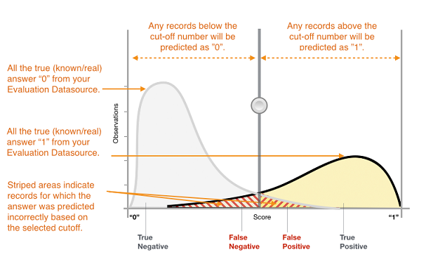
The predictions now fall into four groups based on the actual known answer and the predicted answer: correct positive predictions (true positives), correct negative predictions (true negatives), incorrect positive predictions (false positives) and incorrect negative predictions (false negatives).
Depending on your business problem, you might be more interested in a model that performs well for a specific subset of these metrics. For example, two business applications might have very different requirements for their ML models:
One application might need to be extremely sure about the positive predictions actually being positive (high precision) and be able to afford to misclassify some positive examples as negative (moderate recall).
Another application might need to correctly predict as many positive examples as possible (high recall) and will accept some negative examples being misclassified as positive (moderate precision).
In Amazon ML, observations get a predicted score in the range [0,1]. The score threshold to make the decision of classifying examples as 0 or 1 is set by default to be 0.5. Amazon ML allows you to review the implications of choosing different score thresholds and allows you to pick an appropriate threshold that matches your business needs.
For the given use-case, the classification model predicts if a customer is likely to churn. This implies that a False Negative is very costly for the company because the model predicted that the customer will not churn, however, in reality the customer did churn. So the ideal model would focus on reducing the False Negatives. Thus Model A is the right choice.
Incorrect options:
Model B
As discussed above, Model B is not the right choice as it has more False Negatives.
Both Model A and Model B are equally cost effective, as accuracy is same - Accuracy is not the right criteria to assess the model, as we need to reduce the False Negatives in order to reduce the costs to the company.
None of the Model A and Model B are cost effective. Company needs to try something different - This option has been added as a distractor.
Reference:
https://docs.aws.amazon.com/machine-learning/latest/dg/binary-classification.html
Domain
Modeling
Question 6Skipped
The data science team at a financial services company has created a multi-class classification model to segment the company’s customers into three tiers - Platinum, Gold and Silver. The confusion matrix for the underlying model was reported as follows:
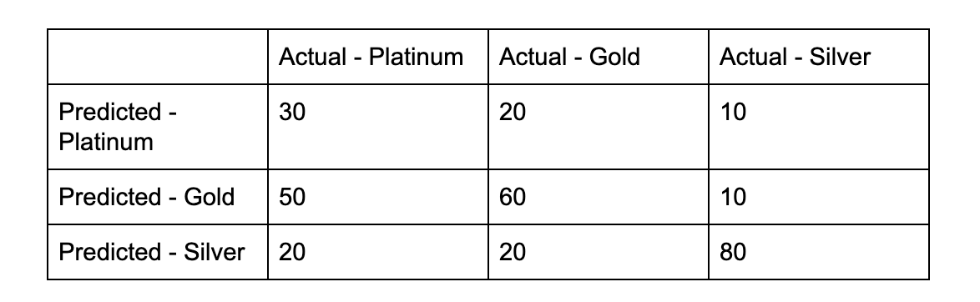
What is the overall precision for this multi-class classification model?
0.50
0.47
Correct answer
0.56
0.67
Overall explanation
Correct option:
0.56

The actual output of a multi-class classification algorithm is a set of prediction scores. The scores indicate the model's certainty that the given observation belongs to each of the classes. Unlike for binary classification problems, you do not need to choose a score cut-off to make predictions. The predicted answer is the class (for example, label) with the highest predicted score.
Amazon ML provides a confusion matrix as a way to visualize the accuracy of multiclass classification predictive models. The confusion matrix illustrates in a table the number or percentage of correct and incorrect predictions for each class by comparing an observation's predicted class and its true class.
An example of confusion matrix is show in the example below:

Precision for Platinum = (True Positives / (True Positives + False Positives))
= (30/(30+ (20+10) )) = 30/60 = 0.50
Precision for Gold = (True Positives / (True Positives + False Positives))
= (60/(60+ (50+10) )) = 60/120 = 0.50
Precision for Silver = (True Positives / (True Positives + False Positives))
= (80/(80+ (20+20) )) = 80/120 = 0.67
Overall Precision = Average of the precision for Platinum, Gold and Silver
= (0.50+0.50+0.67)/3 = 0.56

Incorrect options:
0.50
0.67
0.47
These three options contradict the explanation provided above, so these options are incorrect.
Reference:
https://docs.aws.amazon.com/machine-learning/latest/dg/multiclass-model-insights.html
Domain
Modeling
Question 7Skipped
The ML solutions team at a leading ecommerce company wants to build a real time fraud detection system. As an ML Specialist, what is the recommended course of action to build such a system with the least number of components that also ensures ease of maintenance?
Correct answer
Ingest the clickstream data into Kinesis Data Streams, which is then written into Kinesis Data Analytics for real time fraud detection using the Random Cut Forest Algorithm. A Lambda function sends an email alert for every fraud detected by the algorithm. The processed stream data is finally sent to Kinesis Data Firehose for subsequent storage in S3
Ingest the clickstream data into a Spark Streaming application running on EMR cluster to detect fraud records. The application then writes the data into S3
Ingest the clickstream data into Kinesis Data Streams, which is then written into Kinesis Data Analytics for real time fraud detection and the processed stream data is finally directly written into EFS
Ingest the clickstream data into Kinesis Data Analytics for real time Fraud Detection and the data is finally sent to Kinesis Data Firehose for subsequent storage in S3
Overall explanation
Correct option:
Ingest the clickstream data into Kinesis Data Streams, which is then written into Kinesis Data Analytics for real time fraud detection using the Random Cut Forest Algorithm. A Lambda function sends an email alert for every fraud detected by the algorithm. The processed stream data is finally sent to Kinesis Data Firehose for subsequent storage in S3
Amazon Kinesis Data Analytics is the easiest way to analyze streaming data, gain actionable insights, and respond to your business and customer needs in real time. Amazon Kinesis Data Analytics reduces the complexity of building, managing, and integrating streaming applications with other AWS services. You can quickly build SQL queries and sophisticated Apache Flink applications in a supported language such as Java or Scala using built-in templates and operators for common processing functions to organize, transform, aggregate, and analyze data at any scale.
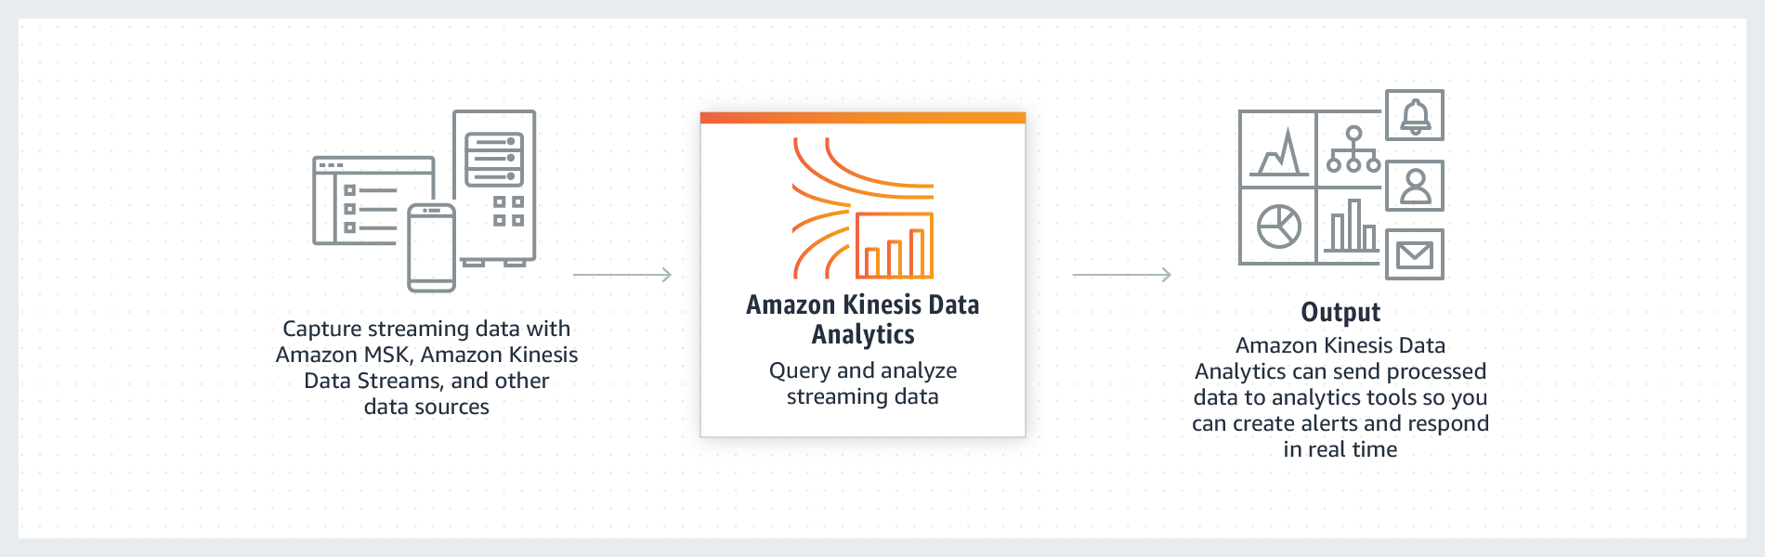
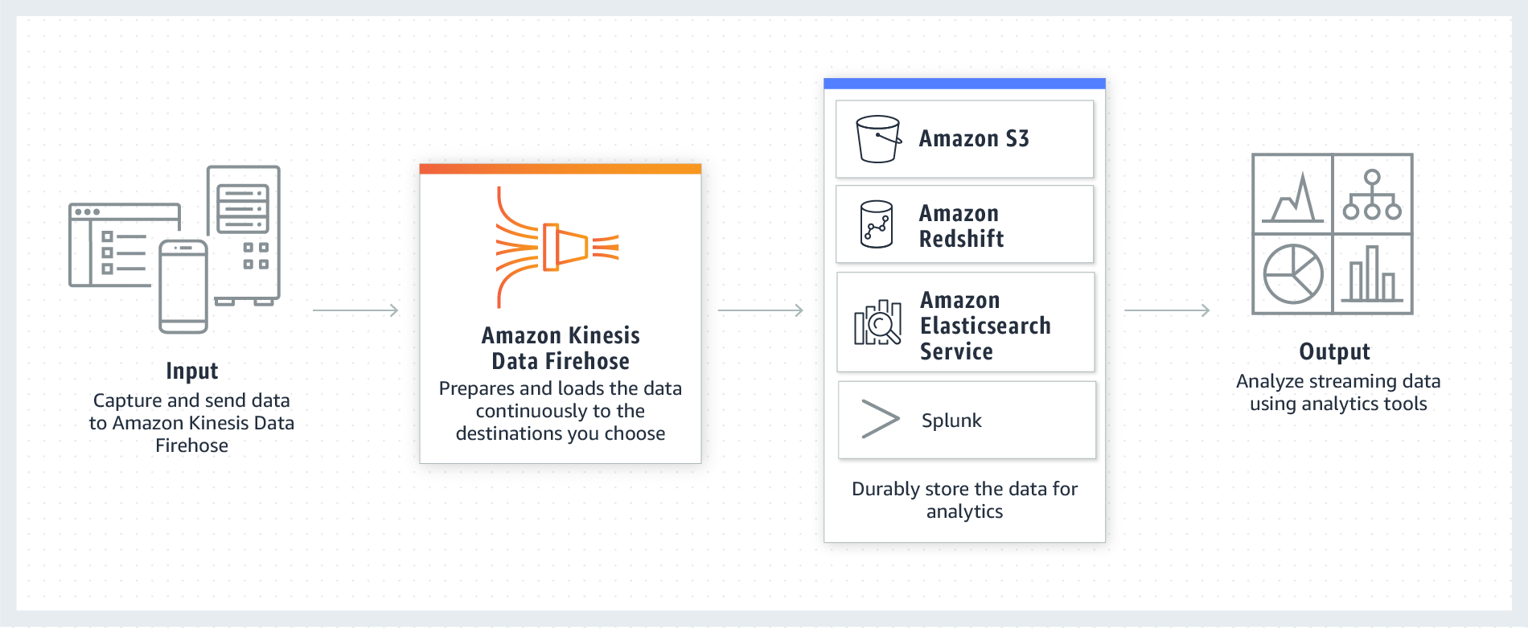

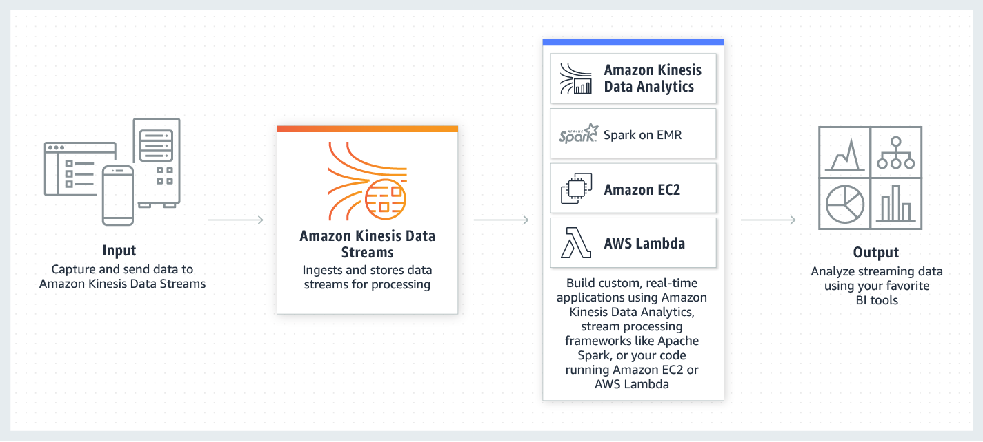
Using the combination of Kinesis Data Streams followed by Kinesis Data Analytics (running RCF algorithm) and then using Kinesis Data Firehose is the correct solution.
Incorrect options:
Ingest the clickstream data into Kinesis Data Analytics for real time Fraud Detection and the data is finally sent to Kinesis Data Firehose for subsequent storage in S3 - Kinesis Data Analytics cannot directly ingest incoming stream data so this option is incorrect. You can use Kinesis Data Streams to ingest the incoming stream data.
Ingest the clickstream data into Kinesis Data Streams, which is then written into Kinesis Data Analytics for real time fraud detection and the processed stream data is finally directly written into EFS - Kinesis Data Analytics cannot directly write data into EFS, so this option is incorrect.
Ingest the clickstream data into a Spark Streaming application running on EMR cluster to detect fraud records. The application then writes the data into S3 - Amazon EMR is a managed cluster platform that simplifies running big data frameworks, such as Apache Hadoop and Apache Spark, on AWS to process and analyze vast amounts of data. By using these frameworks and related open-source projects, such as Apache Hive and Apache Pig, you can process data for analytics purposes and business intelligence workloads. Using an EMR cluster would imply managing the underlying infrastructure so it’s ruled out.
Using an EMR cluster would imply managing the underlying infrastructure so this option is ruled out.
References:
https://aws.amazon.com/kinesis/data-analytics/
https://aws.amazon.com/kinesis/data-streams/
https://aws.amazon.com/kinesis/data-firehose/
Domain
Data Engineering
Question 8Skipped
What technique would you use in SageMaker to train a new model using an expanded dataset that contains an underlying pattern that was not accounted for in the previous training and which resulted in poor model performance?
Batch Training
Transfer Learning
Beta Testing
Correct answer
Incremental Training
Overall explanation
Correct option:
Incremental Training
Over time, you might find that a model generates inferences that are not as good as they were in the past. With incremental training, you can use the artifacts from an existing model and use an expanded dataset to train a new model. Incremental training saves both time and resources.
You can use incremental training to:
Train a new model using an expanded dataset that contains an underlying pattern that was not accounted for in the previous training and which resulted in poor model performance.
Use the model artifacts or a portion of the model artifacts from a popular publicly available model in a training job. You don't need to train a new model from scratch.
Resume a training job that was stopped.
Train several variants of a model, either with different hyperparameter settings or using different datasets.
You can read more on this reference link -
https://docs.aws.amazon.com/sagemaker/latest/dg/incremental-training.html
Incorrect options:
Batch Training - Batch size is a term used in machine learning and refers to the number of training examples utilized in one iteration. The batch size can be one of three options:
batch mode: where the batch size is equal to the total dataset thus making the iteration and epoch values equivalent
mini-batch mode: where the batch size is greater than one but less than the total dataset size. Usually, a number that can be divided into the total dataset size.
stochastic mode: where the batch size is equal to one. Therefore the gradient and the neural network parameters are updated after each sample.
There is no such thing as "batch training" and this option has been added as a distractor.
Beta Testing - Beta Testing is one of the Acceptance Testing types used in traditional software engineering, which adds value to the product as the end-user (intended real user) validates the product for functionality, usability, reliability, and compatibility.
This option has been added as a distractor.
Transfer Learning - This is a technique used in image classification algorithms. The image classification algorithm takes an image as input and classifies it into one of the output categories. Image classification in Amazon SageMaker can be run in two modes: full training and transfer learning. In full training mode, the network is initialized with random weights and trained on user data from scratch. In transfer learning mode, the network is initialized with pre-trained weights and just the top fully connected layer is initialized with random weights. Then, the whole network is fine-tuned with new data. In this mode, training can be achieved even with a smaller dataset. This is because the network is already trained and therefore can be used in cases without sufficient training data.
Transfer Learning is a general machine learning technique that is not relevant to the SageMaker specific use-case described in the question.
Domain
Modeling
Question 9Skipped
An insurance company is building a binary classification model to predict insurance claims. The training data contains 1800 instances of the positive class (customers who did claim insurance) and 100 instances of the negative class (customers who did not claim insurance). The final model has 85% accuracy, but poor precision.
How can you improve the model performance? (Select three)
Correct selection
Over-sample from the negative class
Over-sample from the positive class
Correct selection
Create more samples using algorithms such as SMOTE
Collect more training data for the positive class
Correct selection
Collect more training data for the negative class
Overall explanation
Correct options:
Over-sample from the negative class
Collect more training data for the negative class
Create more samples using algorithms such as SMOTE
In case of a binary classification model with strongly unbalanced classes, we need to over-sample from the minority class, collect more training data for the minority class and create more samples using algorithms such as SMOTE which effectively uses a k-nearest neighbours approach to exclude members of the majority class while in a similar way creating synthetic examples of a minority class. Here are a few good references :
http://www.svds.com/learning-imbalanced-classes/
https://stats.stackexchange.com/questions/235808/binary-classification-with-strongly-unbalanced-classes
Incorrect options:
Over-sample from the positive class
Collect more training data for the positive class
Over-sampling from the positive class or collecting more training data for the positive class would further worsen the model.
Domain
Exploratory Data Analysis
Question 10Skipped
As an ML Specialist, you observe that one of the features used in a SageMaker Linear Learner model had 30% missing data. You also believe that this specific feature was somehow related to a few other features in the data-set.
Which technique would you use to address the missing data?
Drop the missing feature as 30% missing data would severely distort the overall training data
Correct answer
Use multiple imputations approach via a supervised learning technique that uses other features to figure out the imputed value
Replace the missing values with mean
Replace the missing values with median
Overall explanation
Correct option:
Use multiple imputations approach via a supervised learning technique that uses other features to figure out the imputed value
For the given use-case, you need to prepare the dataset for a machine learning problem and you need to fix missing values. You can fix missing values by applying machine learning to that dataset itself! In multiple imputations approach, you need to generate missing values from the dataset many times. The individual datasets are then pooled together into the final imputed dataset, with the values chosen to replace the missing data being drawn from the combined results in some way.The multiple imputations approach breaks imputation process into three steps: imputation (multiple times), analysis (staging how the results should be combined), and pooling (integrating the results into the final imputed matrix). There are a variety of multiple imputation algorithms and implementations available. The most popular algorithm is called MICE.
Here is a great reference for a deep-dive on the multiple imputations approach:
https://www.kaggle.com/residentmario/simple-techniques-for-missing-data-imputation
Incorrect options:
Drop the missing feature as 30% missing data would severely distort the overall training data
Dropping the feature is not recommended as we can impute the missing values for the feature via a supervised learning technique that uses other features to figure out the imputed value.
Replace the missing values with mean
Replace the missing values with median
Replacing with mean or median can introduce bias into the model as these are naive methods, therefore both these options are incorrect.
Domain
Exploratory Data Analysis

